IoT based Weather Predictive Analysis

Nayak Swadesh  
School Of Computer Engineering, KIIT Deemed to be University, Bhubaneswar, India

Jha_Diksha School Of Computer Engineering, KIIT Deemed to be University, Bhubaneswar, India

Jaiswal Tanaya  
School Of Computer Engineering, KIIT Deemed to be University, Bhubaneswar, India

Anand_Divya School Of Computer Engineering, KIIT Deemed to be University, Bhubaneswar, India

Mondal Chiranjit  
School Of Computer Engineering, KIIT Deemed to be University, Bhubaneswar, India

**Abstract:-Climate forecasting is the use of science and technology to predict the atmospheric conditions for a given place and period. People have attempted to informally and formally forecast the weather for centuries since the 19th century. Climate predictions are created by gathering objective data about the current condition of the atmosphere at a given location and using meteorology to predict how the atmosphere will change. Weather forecasting stations are systems that allow forecasting of daily, weekly or monthly weather conditions. These systems, which are used by meteorology in our country, can be both difficult and costly for individual use. So we developed our own weather sensing device with few sensors and a dedicated system. [6] It provides an efficient weather reporting system for users without using Internet.**

***Keywords:IoT,weather_predicting,Sensors,Arduino, microcontroller***

1. **INTRODUCTION**

IoT is robust, precise, secure, and controllable through an established network consisting of devices such as sensors, actuators, smartphone12 linked over the internet. It is the future technology of connecting the whole world together in one place. All objects, items, and sensors can be linked to exchange data collected at different locations and process / analysis data to coordinate applications such as traffic signaling, mobile health monitoring in medical applications, and methods ensuring industrial safety, etc. An estimated 50 billionitems will be connected to IoT by 2020, according to the technology experts.

IOT provides a wide variety of computer communication with various protocols and specific application properties to receive the complete machine to machine interaction. It is a large, precise, effective, and controllable network-wide. Unlike the country's weather forecasting systems used in meteorology, our IoT-based weather forecasting system is cost-effective and has fewer sensors, such as farmers, with a dedicated system for individual use.This IoT based system allows transmission of weather parameters to the microcontroller (ARDUINO UNO) which processes the data and keep on transmitting it to the localhost web server through Ethernet cable without the need of internet. The data is updated live to be viewed on the localhost server system. The various sensors used in the weather forecasting systems are humidity sensors (DHT-11), temperature sensors (DHT-11), rainfall sensors, RGB sensors for getting the data of humidity, temperature, rainfall, the intensity of red, blue and green light respectively. The data collected by localhost can be used by farmers for their planning in crop sowing also for data analysis, ML and various research work.

Let’s imagine a situation where scientists/nature analysts want to monitor changes in a particular environment say volcano or a rain-forest. And these people are from different places in the world. In this case, [SMS based weather monitoring](https://www.projectsof8051.com/sms-based-weather-report-information-system/) has its own limitations. Since it sends SMS to few numbers. And time for sending SMS increases as the number of mobile numbers increases. In order to send this data to everyone, a person who receives this SMS can upload/add data to some place where everyone can see it. And what else apart from the Internet connects everyone in this world? However, a person doing it manually is time consuming and tedious job. And then there arises a need of an automated solution for this. So in such scenarios, IOT – Internet of Things proves really effective. Using Internet of Things, we can upload these weather parameters data to the cloud using internet connectivity over a WiFi module through wireless communication. Thus this project is also categorized under Wireless communication projects.

To view this weather coverage over the Internet, two things are needed. One is the Internet and the other is a device for accessing a website / URL. This may be a laptop or a mobile, a computer or even a smartphone. NOTE that connectivity to the Internet is required in both locations. One is the placement of the project and another is the monitoring of this data by the user.

1. **LITERATURE SURVEY**

The current framework model has introduced IOT-based weather monitoring and reporting system where the calculated data can be recorded, processed , analyzed and displayed on a webserver. Wireless network management model for the sensor consists of end devices, router, gateway node and monitoring center for management. The end device is responsible for collecting and sending data from the wireless sensor network to the parent node, then sending data either directly or by the router to the gateway node.

Firstly, the survey has done to create a standard sensor network on standard technologies. The research went on to find correct standard sensors. This should be sufficient in all respects, such as economically viable and technically achievable. The primary concern that we have to address when choosing the communication method is the communication range. If we send an Internet source, the data can be shared via its IP address anywhere in the world.

We have also worked on selecting the micro-controller. The system implementation is contained with a hidden goal of achieving low power consumable solution. The micro-controller should be also low power consuming alongside all the remaining sensors following the same strategy.[5][6]

The following study went for a data logger to store sensor output data. Most of the data collected from the sensors are in the form of integer values which represent the value of the environmental parameter. The web page that shows sensor data directly does not give the users a simpler impression. For easy user comprehension it should be in a graphical representation. The data that we host on our web page will be easier to interpret and understand. Here we preferred some free data hosting websites which provide our sensor data with a cloud space to make it universal and also make the system financially suitable.

1. **SYSTEM DESIGN**

Weather station systems are large, robust, and flexible. The planning problems are therefore the main reason why these systems are considerably required to be usable. For instance, most airline companies and transport systems need to prepare their schedule based on climatic conditions and the changes that can be encountered. On the other hand, the architecture specifications of these great systems are not necessarily inexpensive systems that routinely track and supervise large cities.[1] This report illustrates a simple way of assessing the cost and performance of such a significant system. Therefore, this work establishes data accumulation record center to start weather forecasting tasks. Arduino Microcontroller 's success and dominance have played a great role in increasing this job. Four sensors are used in this project to realize attributes of weather stations to establish the proposed accumulation framework for the database. DHT sensor that measures the Temperature (T) and Humidity (H). The report is denoted as the output of the sensor that can be restricted and employed by micro-controller program code, such that the micro-controller in a low (T) and high (H ) level can turn the heater ON, and vice verse in case of high (T) and low (H) inside the house. [14][24] Moreover, the system module can operate another device (Air conditioner) represented by a Fan depending on the sensor output in case of extremely high (T) levels and low (H) to keep the house in a cool weather condition.

1. **ARCHITECTURE**

The Arduino 1.8.5 was the best accessible gadget to use the accessible open-source platforms in terms of specification, cost and development devices. Arduino is used as the basis for all types of equipment in this project. The atmosphere parameters must be transmitted to the gadget and after that to the Xampp server for storing the values which we can later use as input data set for applying Machine Learning algorithms.[1]

The weather forecasting system consists of the following components:

Arduino 1.8.5

DHT-11 Temperature & Humidity Sensor

Rainfall Sensor

RGB sensor

Ethernet shield

Ethernet cable

Ethernet is used to send data from the device to the local server where the user can see the information in the MySQL server and download the information and apply Machine Learning Techniques.

1. **COMPONENTS USED**

Arduino 1.8.5:

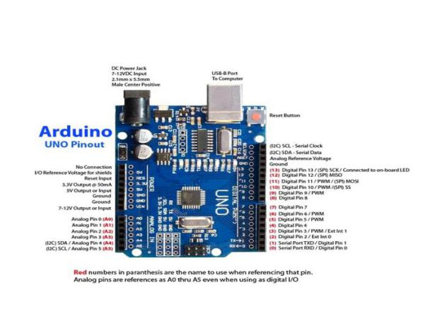

Fig. 1: Arduino 1.8.5

Arduino is an open-source, hardware and software-based electronics platform. Arduino boards can read inputs-light on a sensor , a finger on a button, or a Twitter message-and transform it into an output-trigger a motor, switch on an LED, and publish something online.[1] You can tell your board what to do by sending a set of instructions to the microcontroller on the board.

DHT-11 Temperature & Humidity Sensor:

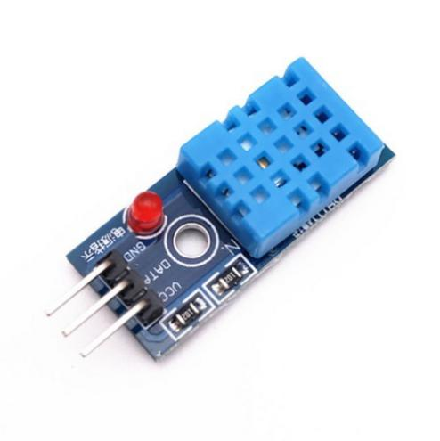

Fig. 2: DHT-11

It includes a segment detecting humidity, an NTC temperature sensor (or thermistor) and an IC at the sensor's rear. The section detecting humidity has two anodes with substratum retaining dampness in between. When the humidity increases, the conductivity of the substratum increases, or the protection between these changes in the electrode that is measured and prepared by the IC and humidity value is determined. As the temperature builds the NTC thermistor resistance diminishes resulting in the expansion of output voltage which at that point prepared by the IC what's more, the temperature value is ascertained.[3][19][20]

Rainfall Sensor:

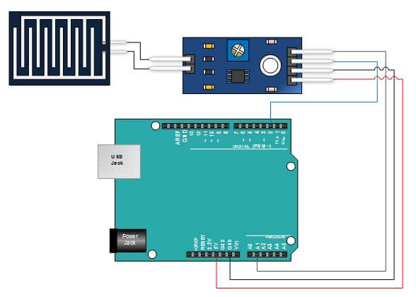

Fig. 3: Rainfall sensor

The weather sensor module is a basic weather identifying instrument. It can be used as a switch when the raindrop falls through the sprinkling board and also for calculating the strength of the precipitation. The module includes, an appended rain board and control board for added comfort, LED power. The analog output is utilized as a part of discovery of drops in the measure of rainfall[19]. Associated with 3.3V/5V power supply and the sensor works in light of the level of the water interfacing the rain board, the output voltage of the gadget varies on the length of the rain board being wet which is changed over to digital through ADC chip.

RGB sensor:

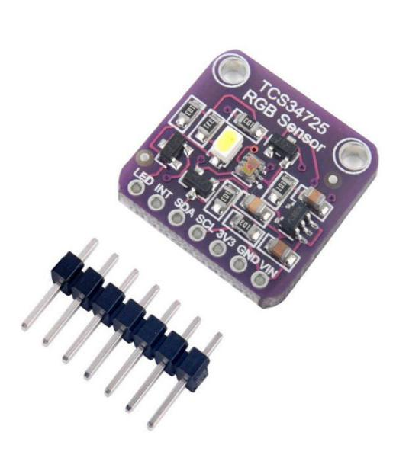

Fig. 4: RGB sensor

RGB color model is for the sensing, representation, and display of images in electronic systems, such as televisions and computers, though it has also been used in conventional [photography](https://en.wikipedia.org/wiki/Photography). Before the [electronic age](https://en.wikipedia.org/wiki/Electronic_age), the RGB color model already had a solid theory behind it, based in [human perception of colors](https://en.wikipedia.org/wiki/Trichromacy).

RGB is a device-dependent color model: different devices detect or reproduce a given RGB value differently, since the color elements (such as [phosphors](https://en.wikipedia.org/wiki/Phosphor) or [dyes](https://en.wikipedia.org/wiki/Dye)) and their response to the individual R, G, and B levels vary from manufacturer to manufacturer, or even in the same device over time. Thus an RGB value does not define the same color across devices without some kind of [color management](https://en.wikipedia.org/wiki/Color_management).

This article discusses concepts common to all the different color spaces that use the RGB color model, which are used in one implementation or another in color image-producing technology.

ETHERNET CABLE:

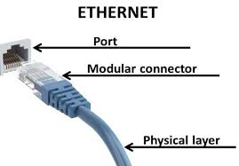

The common form of network cable associated in wired networks is an Ethernet cable. Ethernet cables connect devices within a local area network, such as PCs, routers , and switches. Those physical cables are constrained by reliability and duration. If a network cable is too long or of low quality, otherwise a strong network signal will not be carried. Such limitations are one reason why various types of Ethernet cables are configured in particular circumstances to accomplish those tasks. Plug in Ethernet cables, which are larger than phone cable ports. On a computer an Ethernet port is accessible via the motherboard's Ethernet card.This port is usually on the back of a desktop computer, or on the side of a laptop. Ethernet cables are manufactured in two basic forms:

Solid Ethernet cables deliver a significantly better efficiency and protection from electrical interference. These are also widely used on business networks, cabling to fixed positions within office walls or under lab floors.

Stranded Ethernet cables are less prone to physical cracks and breaks, making them better suited for travelers or in-home network setups.

ARDINO ETHERNET SHIELD:

The Arduino Ethernet Shield enables access to the internet by an Arduino device. It is based on the ethernet chip (datasheet) of Wiznet W5100. The Wiznet W5100 offers a TCP- and UDP-capable network (IP) stack. It supports up to four connections concurrent to the socket. Use the Ethernet library to write sketches that use shield to connect to the internet. The ethernet shield uses long wire-wrap headers that pass across the shield to connect to an Arduino device. It leaves the pin structure intact and allows mounting of another shield on top.

The Ethernet shield uses digital pins 11, 12, 13, 10, and 4 for SPI communication with the W5200 Ethernet controller and SD card. Therefore, the shield is compatible with any other shield that does not use pins 10, and 4 in this regard.

1. **PROJECT PLANNING**

Weather forecasting is the application of science and technology to predict the conditions of the atmosphere for a given location and time IoT based weather forecasting system is cost-effective and have fewer sensors with a dedicated system for individual use such as farmers.

This IoT based system allows transmission of weather parameters to the Micro-controller (ARDUINO UNO) which processes the data and keeps on transmitting it to the localhost webserver through Ethernet cable. The data is updated live to be viewed on the localhost server system. [26]

The various sensors used in the weather forecasting systems are humidity sensors (DHT-11), temperature sensors (DHT-11), rainfall sensors, RGB sensors for getting the data of humidity, temperature, rainfall, the intensity of red, blue and green light respectively. The code for Arduino is written in the Arduino software while the database is created in the Xampp, which accesses data from the Arduino and then displays the result on the localhost. This data is the weather information of the current environment where the device is kept. The data changes by changing the environment of the device.

1. **IMPLEMENTATION**

The block diagram shows how the sensors are connected to the local server through the Arduino UNO microcontroller Ethernet cable. The data then gets stored in the Local Database.[24][25]. This system takes input from the sensors and the output is logged in the local database. The DHT11 sensor detects the humidity and the temperature ans is connected with the Arduino through the digital pin’07’. The RGB sensor detects the Green, Red and Blue light in the environment, it has three connections i.e. the green colour source, blue colour source and the blue colour source is connected to the Arduino through the A1, A2 and the A3 pins of the Arduino respectively. The Rainfall sensor is used in this device to detect whether it is raining or not, it detects the presence of rain.. It is connected to the arduino through A0 pin for analog reading and the D0 pin for digital reading of the device. The Arduino device is then connected to the Local Server with the help of Ethernet cable. The database is created in the local server using Xampp and the it is live updated to be viewed on the local host server system.

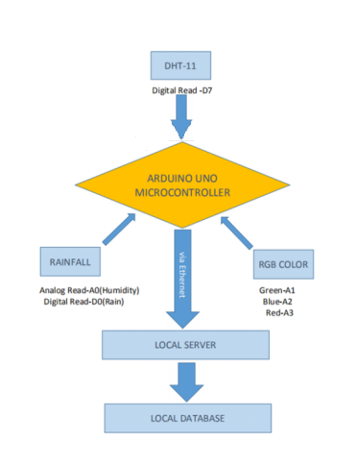

Fig. 5: Block diagram of the implementation of the device

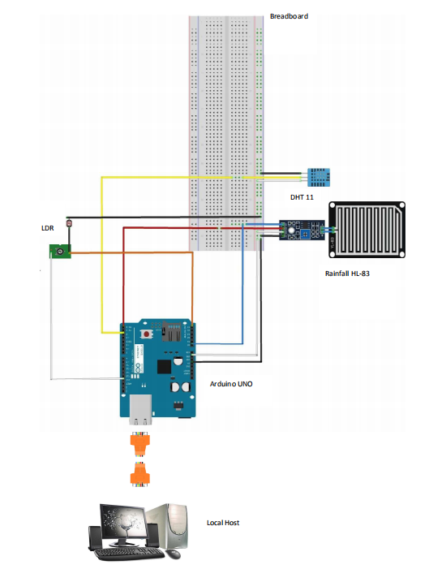Fig. 6: Rough Circuit Diagram

1. **PIN CONFIGURATION**

|  |  |  |
| --- | --- | --- |
| **SENSOR** | **SENSOR PIN** | **BOARD PIN** |
| Rainfall | Analog Read  Digital Read  VCC  Ground  A0  D0  VCC  GND | A0  D0  VCC  GND |
| DHT 11 | VCC  Signal  Ground | VCC  D2  GND |
| RGB Sensor | VCC  Red  Blue  Green  Ground | VCC  A3  A2  A1  GND |

Fig. 7: Pin configuration of Arduino

1. **CODE**

<https://drive.google.com/file/d/1ssagwGWsB-9Z3wLJc6EU96VVcIUkxDU6/view?usp=sharing>

1. **GOALS AND SCOPES**

*IOT weather mentoring system project using Arduino UNO is fully automated system.

*It will not require any human attention.

*We will get prior information on the weather report.

*The costs and efforts will be less in the system.

*The system will allow the human population to live tension free of any natural disaster.

*Accuracy will be high and hence life protection due to prior warnings will be helpful in case of natural disaster.

1. **ESTIMATED COST OF THE SYSTEM**

|  |  |  |  |  |
| --- | --- | --- | --- | --- |
| Sl. No | Item Name | Quantity | Price | Amount |
| 1 | Arduino UNO | 1 | 250 | 250 |
| 2 | Ethernet Shield | 1 | 300 | 300 |
| 3 | DHT 11 Sensor | 1 | 150 | 150 |
| 4 | Rainfall Sensor | 1 | 110 | 110 |
| 5 | RGB Color Sensor | 1 | 165 | 165 |
| 6 | Wire | - | 100 | 100 |
| 7 | Ethernet Cable | 1 | 150 | 150 |
| **Total** | | | | 1225 |

1. **FUTURE DEVELOPMENT**

Since this device right now is only capable of giving the real-time data, there is still a lot of information we can yield from this device. Presently we are working on apply Machine Learning Algorithms to refine data that we are getting from the IoT device and also use the same to predict weather forecast. Also, we are planning to make this entire project user-friendly by developing an application that can be used in android devices.[7]

1. **CONCLUSION**

The key slogan was to use the inexpensive components and achieve the highest accuracy device that could track the weather in the real-time application in agricultural land Weather prediction was a major challenge from the early days, new methodologies clustering daily replacing the old ones. The next wave in the computing era is out of the traditional desktop realm. In the paradigm of the Internet of Things ( IoT), many of the objects which surround us will be in one form or another on the network. Machine learning has a close link with the internet of things. A perfect combination of them can promote the fast development of agricultural modernization, realize smart agriculture, and effectively solve the issues concerning agriculture, countryside, and farmers.

1. **ACKNOWLEDGEMENT**

We are profoundly grateful to Prof. SUJOY DATTA for his expert guidance and continuous encouragement throughout to see that this project rights its target since its commencement to its completion.

*The completion and final outcome of this project required a lot of guidance and assistance from many people and we are extremely privileged to have got this all along the completion of our project. All that we have done is only due to such supervision and assistance and we would not forget to thank them.*

1. **REFERENCES**
2. Anita M. Bhagat| Ashwini G. Thakare | Kajal A. Molke |Neha S. Muneshwar | Prof. V. Choudhary "IOT Based Weather Monitoring and Reporting System Project" Published in International Journal of Trend in Scientific Research and Development(ijtsrd).
3. M.K. Nallakaruppan & U. Senthil Kumaran 2019, January. IoT based Machine Learning Techniques for Climate Predictive Analysis. In: International Journal of Recent Technology and Engineering (IJRTE) ISSN: 2277-3878, Volume-7 Issue-5S2
4. Arduino.cc
5. Deshmukh A. D. &Shinde U. B. 2016, August. A low cost environment monitoring system using raspberry Pi and arduino with Zigbee. In: Inventive Computation Technologies (ICICT), International Conference on. 3: 1-6. IEEE.
6. Wikipedia.com
7. device.(<https://guides.library.bloomu.edu/litreview>)
8. Hasan, Forat & Mahmood, Sarmad. (2017). Design of Weather Monitoring System Using Arduino Based Database Implementation ------------------------------------------------------------------------------------------- http://www.jmest.org/wp-content/uploads/JMESTN42352157.pdf. http://www.jmest.org/wp-content/uploads/JMESTN42352157.pdf. 4. 2458-9403.
9. Jindarat S. &Wuttidittachotti P. 2015, April. Smart farm monitoring using Raspberry Pi and Arduino.In: Computer. Communications, and Control Technology (I4CT), 2015 International Conference on . IEEE. pp. 284-288.
10. Savić T. &Radonjić M. 2015, November. One approach to weather station design based on Raspberry Pi platform. In: Telecommunications Forum Telfor (TELFOR), 23rd . IEEE. pp. 623-626.
11. Wang Y. & Chi Z. 2016, July. System of Wireless Temperature and Humidity Monitoring Based on Arduino Uno Platform. In: Instrumentation & Measurement, Computer, Communication and Control (IMCCC), 2016 Sixth International Conference on. IEEE. pp. 770-773.
12. Saini H., Thakur A., Ahuja S., Sabharwal N. & Kumar N. 2016, February. Arduino based automatic wireless weather station with remote graphical application and alerts. In: Signal Processing and Integrated Networks (SPIN), 2016 3rd International Conference on. IEEE. pp. 605-609.
13. Kumar N. P. &Jatoth R. K. 2015 May. Development of cloud based light intensity monitoring system using raspberry Pi. In: Industrial Instrumentation and Control (ICIC), 2015 International Conference on.IEEE. pp. 1356-1361.
14. Srinivasan V. S., Kumar T. &Yasarapu D. K. 2016, May. Raspberry Pi and iBeacons as environmental data monitors and the potential applications in a growing BigData ecosystem. In: Recent Trends in Electronics, Information & Communication Technology (RTEICT), IEEE InternationalConference on. IEEE. pp. 961-965.
15. Ibrahim M., Elgamri A., Babiker S. & Mohamed A. 2015, October. Internet of things based smart environmental monitoring using the raspberry-pi computer. In: Digital Information Processing and Communications (ICDIPC), 2015 Fifth International Conference on. IEEE. pp. 159-164.
16. Folea S. C. &Mois G. 2015. A low-power wireless sensor for online ambient monitoring. IEEE Sensors Journal. 15(2): 742-749
17. Sandeep V., Gopal K. L., Naveen S., Amudhan A. & Kumar L. S. 2015, August. Globally accessible machine automation using Raspberry pi based on Internet of Things. In: Advances in Computing, Communications and Informatics (ICACCI), 2015 International Conference on. IEEE. pp. 1144-1147.
18. K. Krishnamurthi, S. Thapa, L. Kothari, A. Prakash, “Arduino Based Weather Monitoring System” International Journal of Engineering Research and General Science Volume 3, Issue 2, March, April, 2015.

1. N. Sabharwal, R. Kumar, A. Thakur, J. Sharma "A Low Cost Zigbee Based Automatic Wireless Weather Station With Gui And Web Hosting Facility" ICRTEDC, Vol. 1, Spl. Issue 2, May, 2014.

1. N. Gahlot, V. Gundkal, S. Kothimbire, A. Thite, “Zigbee based weather monitoring system” The International Journal Of Engineering And Science (IJES), Volume 4, Issue 4, PP.61-66, 2015.

1. D-Robotics, UK, DHT11 Humidity & Temperature Sensor datasheet. [online]. Available: https://www.droboticsonline.com , (30/Jul/2010).

1. Xiamen Amotec Display CO,.LTD, Specification of LCD Module LCD datasheet Module- sparkfun.[online].Available:https://www.sparkfun.com/datasheets/LCD. (29, Oct, 2008).

1. D. V. Sose, A. D. Sayyad, “Weather Monitoring Station: A Review” Int. Journal of Engineering Research and Application, ISSN : 2248-9622, Vol. 6, Issue 6, ( Part -1) June 2016, pp.55-60.

1. F. Hahn, M. Pablo, J. Reyes “Solar Driven Wind Speed Monitoring System Using Wireless or Wired Sensors” SciRes, Energy and Power Engineering, Vol 6, PP.213-221, 2014.

1. A. Katyal, R. Yadav, M. Pandey, " Wireless Arduino Based Weather Station" International Journal of Advanced Research in Computer and Communication Engineering Vol. 5, Issue 4, April, 2016.

1. P. Susmitha, G. Sowmyabala “Design and Implementation of Weather Monitoring and Controlling System” International Journal of Computer Applications (0975 – 8887) Volume 97-No.3, July 2014.

1. Tutorials Point, R Programing. [online]. Available: <https://www.tutorialspoint.com/r/r.tutorial>.
2. N. K. Suryadevara, S. C. Mukhopadhyay, Review On IotBased Smart Agriculture, International Journal OfAdvanced Engineering & Innovative Technology (IJAEIT) ISSN: 2348 7208 Published In 2011[5]

1. Vinayak N. Malavade , Pooja K. Akulwar 1,2(Departmentof Computer Science and Engineering, SGI, Atigre, India)Role of IoT in Agriculture IOSR Journal of ComputerEngineering (IOSR-JCE) e-ISSN: 2278-0661,p-ISSN:2278-8727 PP 56-57[6]
2. R. Nandhini , S. Poovizhi , Priyanka Jose , R. Ranjitha , Dr.S. Anila Students- Department of Electronics andCommunication Engineering, Sri Ramakrishna Instituteof Technology, Coimbatore. Associate Professor,Department of Electronics and CommunicationEngineering Sri Ramakrishna Institute Of Technology,Coimbatore. . Arduino based smart irrigation systemusing iot 3 rd National Conference on IntelligentInformation and Computing Technologies, IICT ‘17[7]
3. Mohanraj I*a , Kirthika Ashokumarb , Naren Jc a B. TechComputer Science and Engineering, School ofComputing, SASTRA University,Thanjavur - 613401, India. b B.Tech Computer Science andEngineering, School of Computing,.Field Monitoring and Automation using IOT inAgriculture Domain 6th International Conference OnAdvances In Computing & Communications, ICACC 2016,6-8 September 2016, Cochin, India[8]
4. Yunseop Kim and Robert G. Evans, “Remote Sensing andControl of an Irrigation System using a DistributedWireless Sensor Network” presented at IEEETransactions on Instrumentation and Measurement,Vol57, July-2008.[9]
5. Sjaak Wolfert , Lan Ge , Cor Verdouw Marc-JeroenBogaardt ,Wageningen University and Research, TheNetherlands ,Information Technology Group,Wageningen University, The Netherlands, Big Data inSmart Farming – A review. Article.